Btree Index usage

scripts - V16__Create.sql, V16.1__Insert.sql, V16.2__Create_Index.sql, test.sql  
  
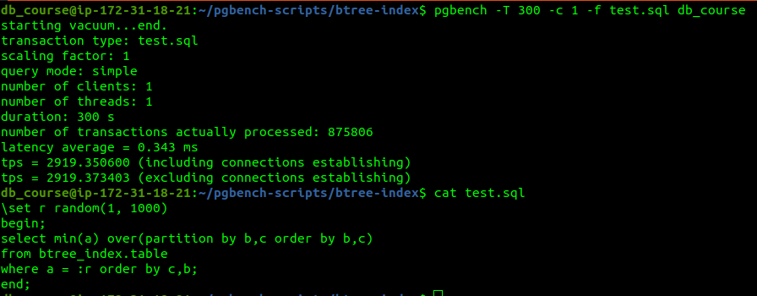  
  


table_a_b_c_idx index has been used